Con il Patrocinio

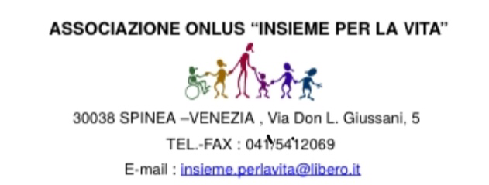

Descrizione delle foto partecipanti al concorso (max 100 caratteri facendo attenzione a non apporre né le generalità, né alcun altro segno distintivo, pena l’esclusione dal concorso)
______________________________________________________________________________________________________________________________________________________________________________
_______________________________________________________________________________________
_______________________________________________________________________________________
_______________________________________________________________________________________
_______________________________________________________________________________________
_______________________________________________________________________________________
_______________________________________________________________________________________
_______________________________________________________________________________________
_______________________________________________________________________________________
_______________________________________________________________________________________

